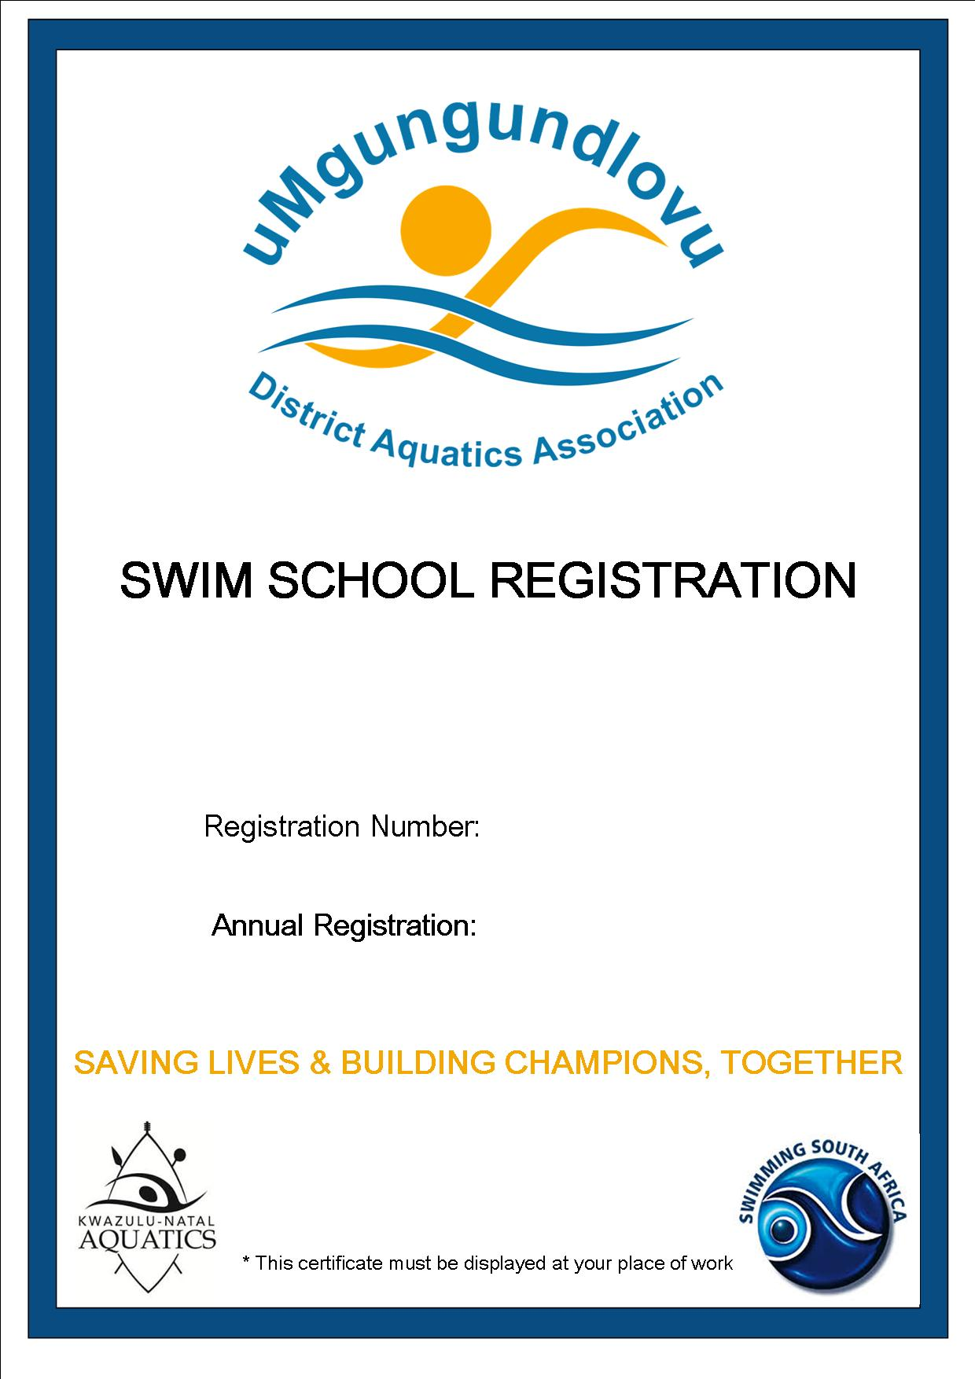

2021 - 2022

UMDM/2020/17

PIETERMARITZBURG

**BUBBLE BLOWERS SWIM SCHOOL**